**Media Queries Assignment**

1. **Create a simple webpage with a header, a main content section, and a footer. Apply a media query that changes the background color of the header to blue when the screen width is less than 600px.**

**Ans: HTML Code:**

**<!DOCTYPE html>**

**<html lang="en">**

**<head>**

**<meta charset="UTF-8">**

**<meta name="viewport" content="width=device-width, initial-scale=1.0">**

**<link rel="stylesheet" href="style.css">**

**<title>Media Queries</title>**

**</head>**

**<body>**

**<h1 id="main-heading">Responsive Header</h1> <br>**

**<main>Main Content</main> <br>**

**<footer>Footer</footer>**

**</body>**

**</html>**

**CSS Code:**

**\* {**

**margin: 0;**

**padding: 0;**

**box-sizing: border-box;**

**font-family: 'Times New Roman', Times, serif;**

**}**

**#main-heading {**

**text-align: center;**

**background-color: #f2f2f2;**

**height: 80px;**

**padding: 15px 0;**

**}**

**@media only screen and (max-width: 600px) {**

**#main-heading {**

**background-color: blue;**

**}**

**main, footer {**

**margin-left: 10px;**

**}**

**}**

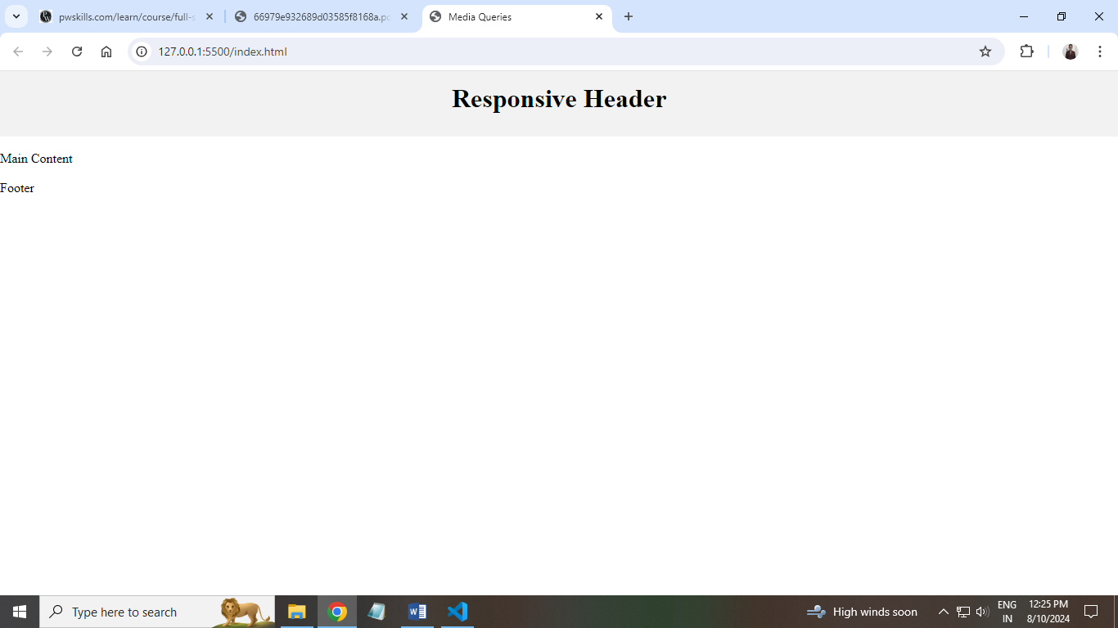

1. 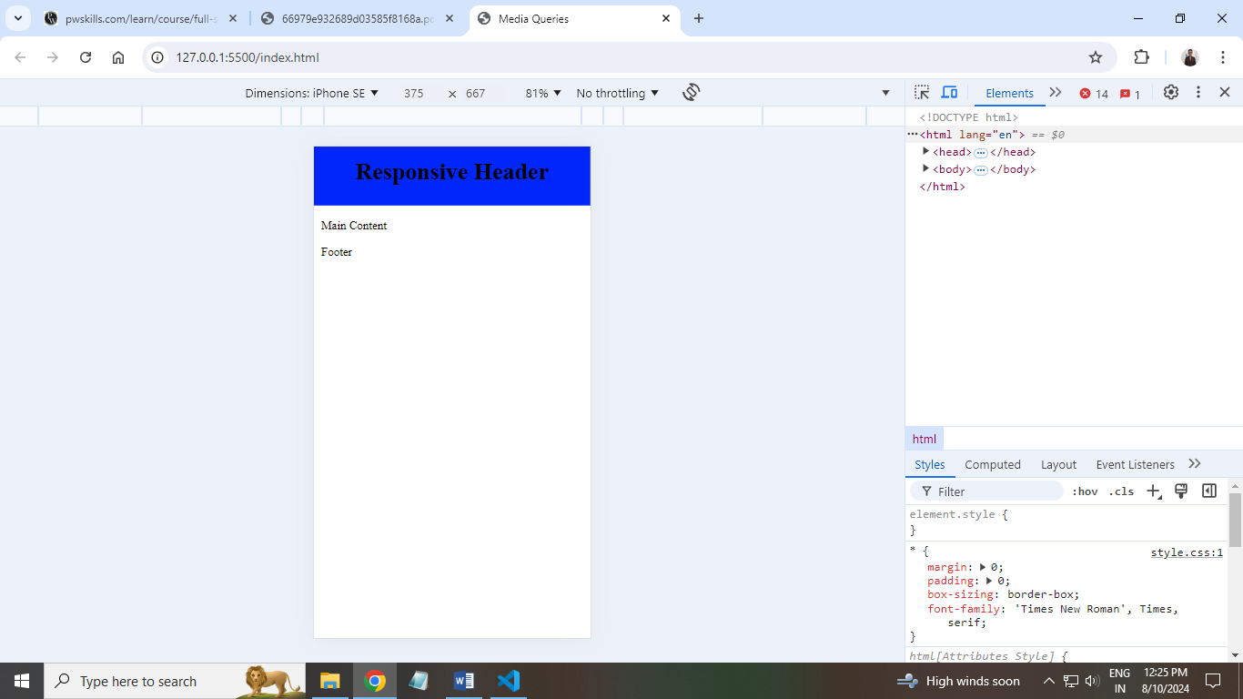**Create an image gallery with three images in a row. Use media queries to adjust the layout to two images in a row for screens smaller than 800px and one image in a row for screens smaller than 500px.**

**Ans: HTML Code:**

**<!DOCTYPE html>**

**<html lang="en">**

**<head>**

**<meta charset="UTF-8">**

**<meta name="viewport" content="width=device-width, initial-scale=1.0">**

**<link rel="stylesheet" href="style.css">**

**<title>Media Queries</title>**

**</head>**

**<body>**

**<div class="image-container">**

**<img src="image1.jpg" alt="Image 1">**

**<img src="image2.jpg" alt="Image 2">**

**<img src="image3.jpg" alt="Image 3" id="image-3">**

**</div>**

**</body>**

**</html>**

**CSS Code:**

**/* Default layout: three images in a row */**

**.image-container {**

**display: flex;**

**flex-wrap: wrap;**

**justify-content: space-around;**

**}**

**.image-container img {**

**width: 350px;**

**height: 500px;**

**margin: 10px;**

**}**

**/* For screens smaller than 800px: two images in a row */**

**@media (max-width: 800px) {**

**.image-container img {**

**width: 300px;**

**height: 440px;**

**}**

**#image-3 {**

**margin-right: 350px;**

**}**

**}**

**/* For screens smaller than 500px: one image in a row */**

**@media (max-width: 500px) {**

**.image-container {**

**flex-direction: column;**

**align-items: center;**

**}**

**.image-container img {**

**width: 300px;**

**height: 450px;**

**}**

**#image-3 {**

**margin-right: 0;**

**}**

**}**

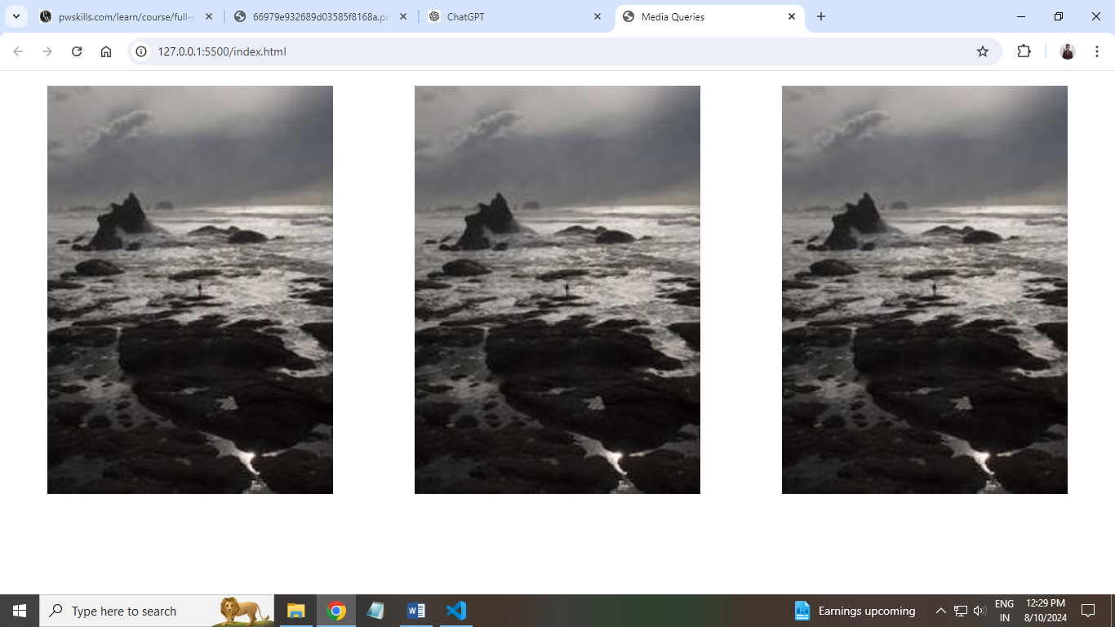

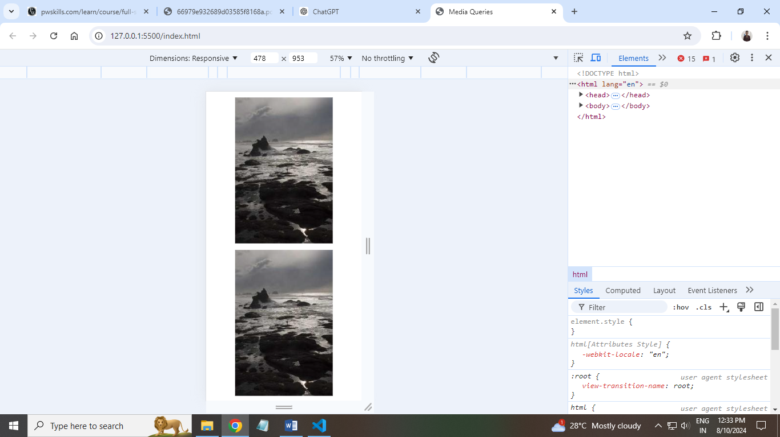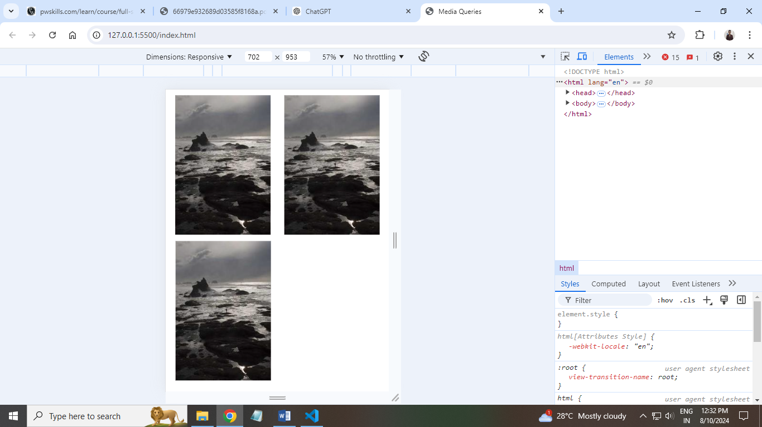

1. **Create a navigation bar with five links. Apply a media query that converts the navigation into a vertical list for screens smaller than 768px and also changes the background color to gray.**

**Ans: HTML Code:**

**<!DOCTYPE html>**

**<html lang="en">**

**<head>**

**<meta charset="UTF-8">**

**<meta name="viewport" content="width=device-width, initial-scale=1.0">**

**<link rel="stylesheet" href="style.css">**

**<title>Nav Bar Design</title>**

**</head>**

**<body>**

**<header>**

**<nav>**

**<ul>**

**<li><a href="index.html">Home</a></li>**

**<li><a href="about.html">About</a></li>**

**<li><a href="services.html">Services</a></li>**

**<li><a href="portfolio.html">Portfolio</a></li>**

**<li><a href="contact.html">Contact</a></li>**

**</ul>**

**</nav>**

**</header>**

**</body>**

**</html>**

**CSS Code:**

**header {**

**height: 80px;**

**background-color: black;**

**color: white;**

**display: flex;**

**align-items: center;**

**justify-content: center;**

**margin-top: 15px;**

**}**

**ul {**

**display: flex;**

**list-style: none;**

**margin-right: 15px;**

**}**

**a {**

**text-decoration: none;**

**color: white;**

**margin: 0 8px;**

**padding: 5px 5px;**

**font-size: 19px;**

**transition: all 0.7s ease;**

**}**

**a:hover {**

**color: red;**

**}**

**@media screen and (max-width: 768px) {**

**header {**

**height: auto;**

**padding: 10px 0px;**

**background-color: gray;**

**}**

**ul {**

**flex-direction: column;**

**text-align: center;**

**}**

**ul li {**

**margin: 10px;**

**}**

**a {**

**font-size: 18px;**

**cursor: pointer;**

**}**

**a:hover {**

**color: red;**

**}**

**#main-para {**

**font-size: 16.5px;**

**text-align: justify;**

**margin: 10px;**

**padding: 10px;**

**}**

**}**

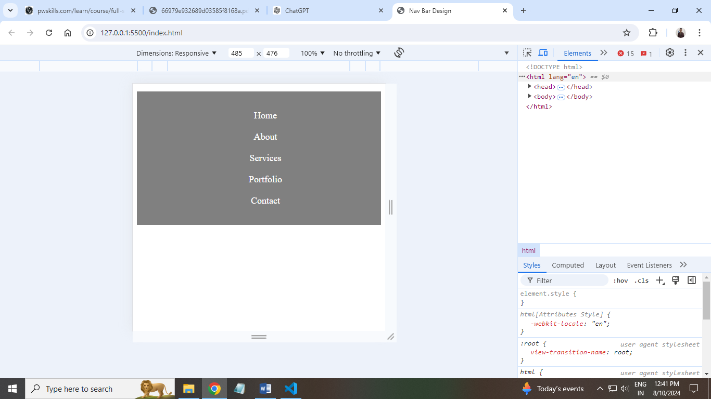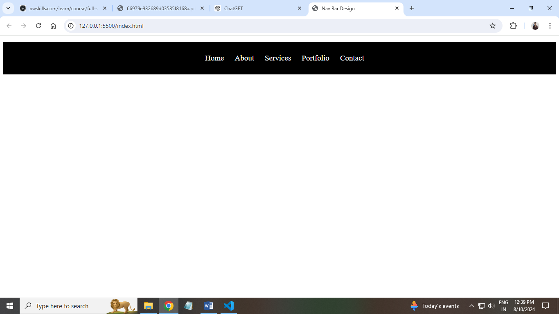

1. **Create a grid based layout containing four grid items which arranges them as the screen size changes.**

**Ans: HTML Code:**

**<!DOCTYPE html>**

**<html lang="en">**

**<head>**

**<meta charset="UTF-8">**

**<meta name="viewport" content="width=device-width, initial-scale=1.0">**

**<link rel="stylesheet" href="style.css">**

**<title>Media Queries</title>**

**</head>**

**<body>**

**<div class="grid-container">**

**<div class="grid-item" id="box-1">Box 1</div>**

**<div class="grid-item" id="box-2">Box 2</div>**

**<div class="grid-item" id="box-3">Box 3</div>**

**<div class="grid-item" id="box-4">Box 4</div>**

**</div>**

**</body>**

**</html>**

**CSS Code:**

**.grid-container {**

**display: grid;**

**grid-template-columns: repeat(3, 1fr);**

**gap: 20px;**

**padding: 25px;**

**}**

**.grid-item {**

**display: flex;**

**justify-content: center;**

**align-items: center;**

**font-weight: bold;**

**width: 380px;**

**height: 200px;**

**color: white;**

**}**

**#box-1 {**

**background-color: red;**

**border: 1px solid red;**

**}**

**#box-2 {**

**background-color: green;**

**border: 1px solid green;**

**}**

**#box-3 {**

**background-color: blue;**

**border: 1px solid blue;**

**}**

**#box-4 {**

**background-color: orange;**

**border: 1px solid orange;**

**}**

**/* Media Query for iPad Air (typically 820px wide) */**

**@media (max-width: 820px) {**

**.grid-container {**

**grid-template-columns: 1fr;**

**gap: 20px;**

**}**

**.grid-item {**

**width: 100%;**

**height: 180px;**

**}**

**}**

**/* Media Query for Tablets (768px to 1024px wide) */**

**@media (max-width: 1024px) and (min-width: 768px) {**

**.grid-container {**

**grid-template-columns: repeat(2, 1fr);**

**}**

**.grid-item {**

**width: 300px;**

**height: 180px;**

**}**

**}**

**/* Media Query for iPhones (up to 812px wide) */**

**@media (max-width: 812px) {**

**.grid-container {**

**grid-template-columns: 1fr;**

**gap: 15px;**

**padding: 20px;**

**}**

**.grid-item {**

**width: 100%;**

**height: 160px;**

**}**

**}**

**/* Media Query for Mobile Phones (up to 480px wide) */**

**@media (max-width: 480px) {**

**.grid-container {**

**grid-template-columns: 1fr;**

**gap: 10px;**

**padding: 15px;**

**}**

**.grid-item {**

**width: 100%;**

**height: 140px;**

**}**

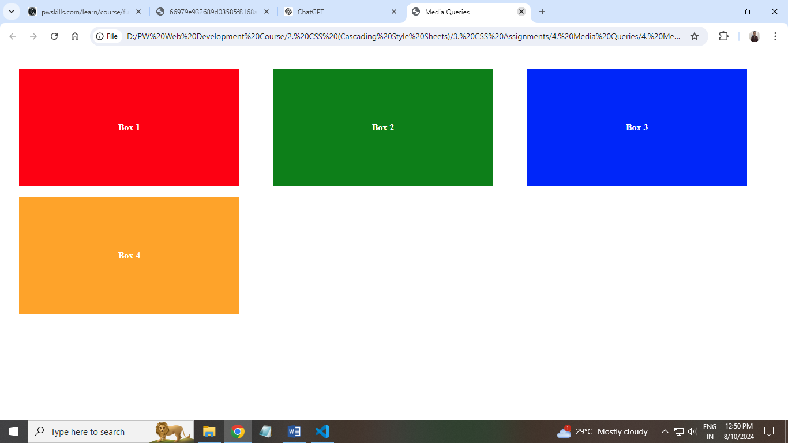**}**

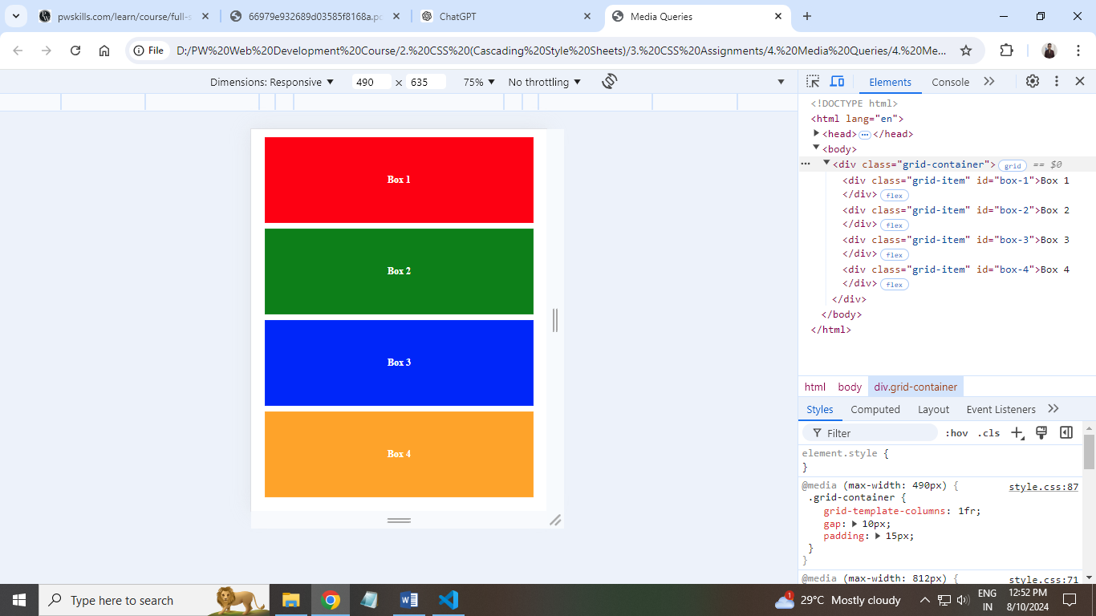

1. **Create the below given layout using the flexbox in css, which should adapt itself on mobile screen as per given below output.**

**Ans: HTML Code:**

**<!DOCTYPE html>**

**<html lang="en">**

**<head>**

**<meta charset="UTF-8">**

**<meta name="viewport" content="width=device-width, initial-scale=1.0">**

**<link rel="stylesheet" href="style.css">**

**<title>Media Query 5</title>**

**</head>**

**<body>**

**<div class="container">**

**<div class="box-1">Box 1</div>**

**<div class="middle-boxes">**

**<div class="box-2">Box 2</div>**

**<div class="box-3">Box 3</div>**

**</div>**

**<div class="box-4">Box 4</div>**

**</div>**

**</body>**

**</html>**

**CSS Code:**

**\* {**

**margin: 0;**

**padding: 0;**

**box-sizing: border-box;**

**font-family: 'Times New Roman', Times, serif;**

**}**

**body,**

**html {**

**height: 100%;**

**}**

**.container {**

**display: flex;**

**justify-content: space-between;**

**height: 100%;**

**}**

**.box-1,**

**.box-4 {**

**width: 100px;**

**height: 641px;**

**background-color: black;**

**color: white;**

**display: flex;**

**justify-content: center;**

**align-items: center;**

**}**

**.middle-boxes {**

**display: flex;**

**flex-direction: column;**

**justify-content: center;**

**align-items: center;**

**}**

**.box-2,**

**.box-3 {**

**width: 1166px;**

**height: 320px;**

**color: white;**

**display: flex;**

**justify-content: center;**

**align-items: center;**

**}**

**.box-2 {**

**background-color: green;**

**}**

**.box-3 {**

**background-color: orange;**

**}**

**@media (max-width: 1024px) {**

**.container {**

**flex-direction: column;**

**justify-content: flex-start;**

**align-items: center;**

**}**

**.box-1,**

**.box-2,**

**.box-3 {**

**width: 250px;**

**height: 200px;**

**margin-bottom: 20px;**

**}**

**.middle-boxes {**

**width: 100%;**

**gap: 10px;**

**}**

**.box-4 {**

**width: 250px;**

**height: 150px;**

**margin-top: 20px;**

**}**

**}**

**/* Responsive Design for Mobile Phones (up to 767px) */**

**@media (max-width: 767px) {**

**.container {**

**flex-direction: column;**

**justify-content: flex-start;**

**align-items: center;**

**}**

**.box-1,**

**.box-2,**

**.box-3 {**

**width: 200px;**

**height: 150px;**

**margin-bottom: 15px;**

**}**

**.middle-boxes {**

**width: 100%;**

**gap: 10px;**

**}**

**.box-4 {**

**width: 200px;**

**height: 100px;**

**margin-top: 20px;**

**}**

**}**

**/* Responsive Design for Small Devices (iPhones) */**

**@media (max-width: 590px) {**

**.container {**

**display: flex;**

**flex-direction: column;**

**}**

**.box-1,**

**.box-2,**

**.box-3**

**{**

**width: 100%;**

**height: 100px;**

**}**

**.box-4 {**

**width: 100%;**

**height: 100px;**

**margin-top: 120px;**

**}**

**}**

